Jennifer Stegina

28 August 2019

CIS 250

**Unit 1 Graded Exercise 1**

The following questions come from the “Check your understanding” examples of each section of Chapter 2 in your textbook.

After you are finished, please submit the Microsoft Word file that contains screenshots of the SQL script and the resulting tables. Your document should be named **U1_GradedExercise1_Lastname.docx**.

(2-4) Question 1:

List the description and price of all the foods. Change the name of the description column to *food_item* and the name of the *price* column to *cost.*

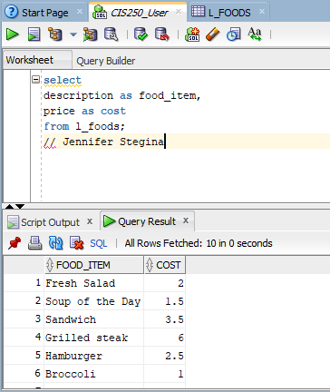

(2-5) Question 2:

**List all the columns and all the rows of the foods table.**

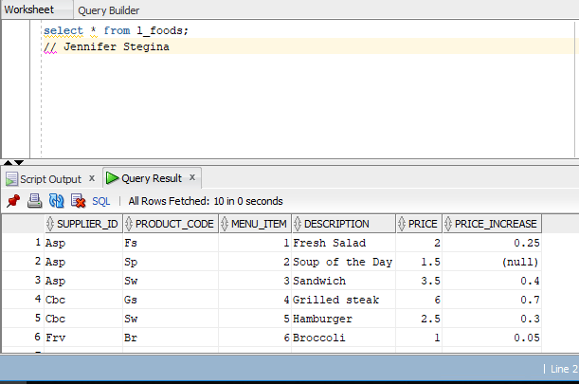

**How many columns are in this table?**

6 columns in this table

**How many rows?**

10 rows in this table

**What are the names of the columns?**

SUPPLIER_ID, PRODUCT_CODE, MENU_ITEM, DESCRIPTION, PRICE, PRICE_INCREASE

(2-6) Question 3:

List all the different *supplier_id* values from the *l_foods* table.

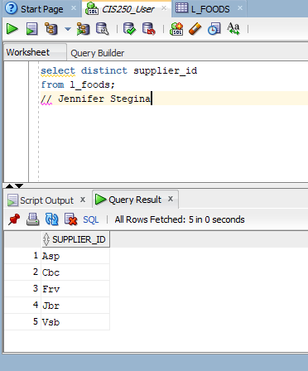

(2-7) Question 4:

List all the different values in columns A and B of the *sec0207* table

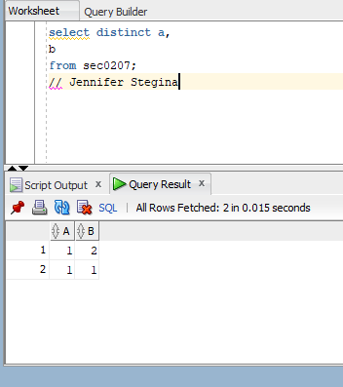

(2-9) Question 5:

List the first name and last name of the employees with the first name of Nancy.

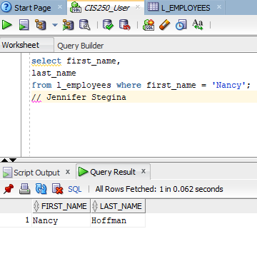

(2-10) Question 6:

List the first name and last name of the employees with *employee_id* greater than or equal to 205.

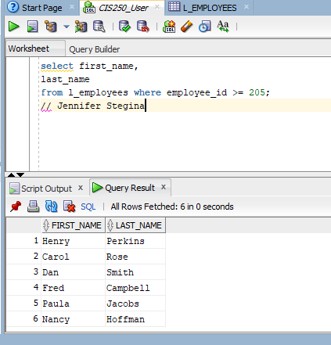

(2-11) Question 7

List the first name and last name of the employees with employee id not equal to 205. Write this in three different ways that all work in the version of SQL you are currently using.

